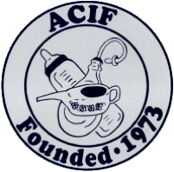

Convention & Annual Dues Form

2024 ACIF CONVENTION

**October 24 - 26, 2024**

York, Maine

**Hotel---- Microtel by Wyndham**

6 Market Place Drive

York, ME 03909

Phone Number: **207-363-0800**

When making reservations reference “ACIF”

Room rates as follows:

* 1 queen bed $125
* 1 queen bed and fold out couch $138
* 2 queen beds $134
* Breakfast included with room price

Please make your reservations by August 22, 2024 to receive the above rates

Convention days this year will be:

* Thursday October 24 – welcome and dinner together
* Friday October 25 – group sightseeing & antiquing, evening program and Fun Fund Auction
* Saturday October 26 – Antiquing, lunch at Jinny and Bob’s and see Jinny’s collections, evening program and Sale

Please indicate who will be attending the 2024 York, Maine Convention.

1__________________________________________________________

2__________________________________________________________

Are you bringing items for the Fun Fund Auction? Tables needed ½_____Full____

Indicate number of tables needed for Saturday night’s sale ½______Full_____

ACIF DUES FOR July 2024 -June 2025 are $40.00

Make checks payable to ACIF (and provide member name(s) and contact information)

MAIL TO: CHARNA SANSBURY, Treasurer

30 White Birch Court, Gibsonville, N.C. 27249